Revisiting AI Project Cycle & Ethical Frameworks for AI
REVISION NOTES

AI PROJECT CYCLE
The AI Project Cycle is a six-stage process for developing an AI project. It provides a structured framework for achieving a project goal.
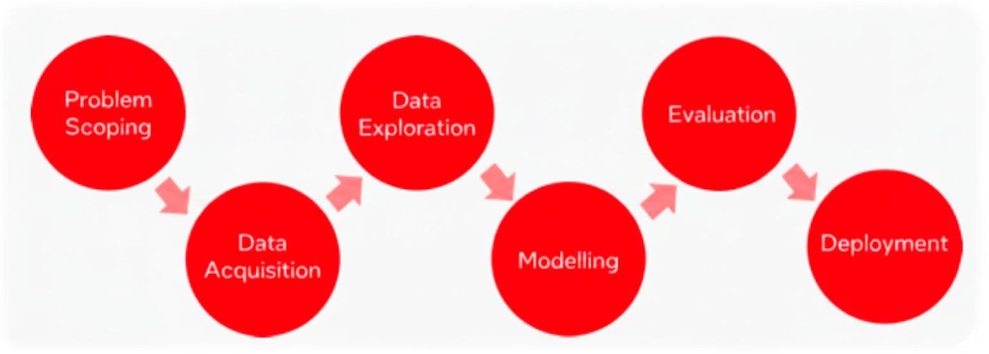
- Problem Scoping: The initial stage where you define the problem you want to solve with AI and look at the various parameters that affect it.
- Data Acquisition: This stage involves collecting data from various reliable and authentic sources to serve as the project's foundation.
- Data Exploration: You visually represent the acquired data using graphs, databases, or other methods to easily interpret patterns.
- Modelling: Based on the data patterns, you select and build an AI model to achieve your goal, and test different models to find the most efficient one.
- Evaluation: The model is tested on new data to evaluate its performance and identify areas for improvement.
- Deployment: The final stage where the AI solution is integrated into real-world environments to deliver value.

AI DOMAINS
AI models are categorized into three broad domains based on the type of data they are trained on.

- Statistical Data: This domain involves systems that collect, maintain, and derive meaning from large datasets to make decisions. An example is a price comparison website.
- Computer Vision (CV): This domain gives a machine the ability to analyze visual information and make decisions based on it. The process includes acquiring, screening, and extracting information from images or videos. Examples include agricultural monitoring and surveillance systems.
- Natural Language Processing (NLP): NLP deals with the interaction between computers and humans using natural language. Its main goal is to enable machines to read, decipher, and understand human language. Examples include email spam filters and machine translation services like Google Translate.

ETHICAL FRAMEWORKS FOR AI
Ethical frameworks are a set of steps or guidelines that help ensure decisions don't cause unintended harm. They provide a structured way to handle complex moral dilemmas. These frameworks are crucial for AI, especially since AI is often used as a decision-making tool.

TYPES OF ETHICAL FRAMEWORKS
Ethical frameworks are classified into two main types.
- Sector-based Frameworks: These are tailored to specific industries or sectors. An example is
Bioethics, used in healthcare and life sciences, which addresses issues like patient privacy and data security.
- Value-based Frameworks: These focus on fundamental ethical principles and moral philosophies. They are further categorized into:
  - Rights-based: Prioritizes human rights and dignity, ensuring AI systems don't violate them or discriminate against groups.
  - Utility-based: Aims to maximize the overall good by weighing the benefits of an action against its potential harm.
  - Virtue-based: Focuses on the character and intentions of the individuals involved, ensuring actions align with virtuous principles like honesty and integrity.
Principles of Bioethics Bioethics is an ethical framework specifically for healthcare and life sciences. Its principles include:
- Respect for Autonomy: Ensuring users are fully aware of how an AI algorithm functions and that data used to train models is accessible and reproducible.
- Do Not Harm (Non-maleficence): The ethical principle of avoiding negative consequences and minimizing harm. AI algorithms should be trained on datasets that equitably reduce harm for all.
- Ensure Maximum Benefit (Beneficence): Not just avoiding harm, but actively promoting well-being and striving for the greatest good for all stakeholders. This includes using unbiased data for training.
- Give Justice: All benefits and burdens of a choice must be distributed fairly and justly, regardless of a person's background.
